NAME: P. PADMAKAR

REG.NO: 19125041

DAY-1 EXPERIMENTS

1.Addition:

a=1

b=4

sum=a+b

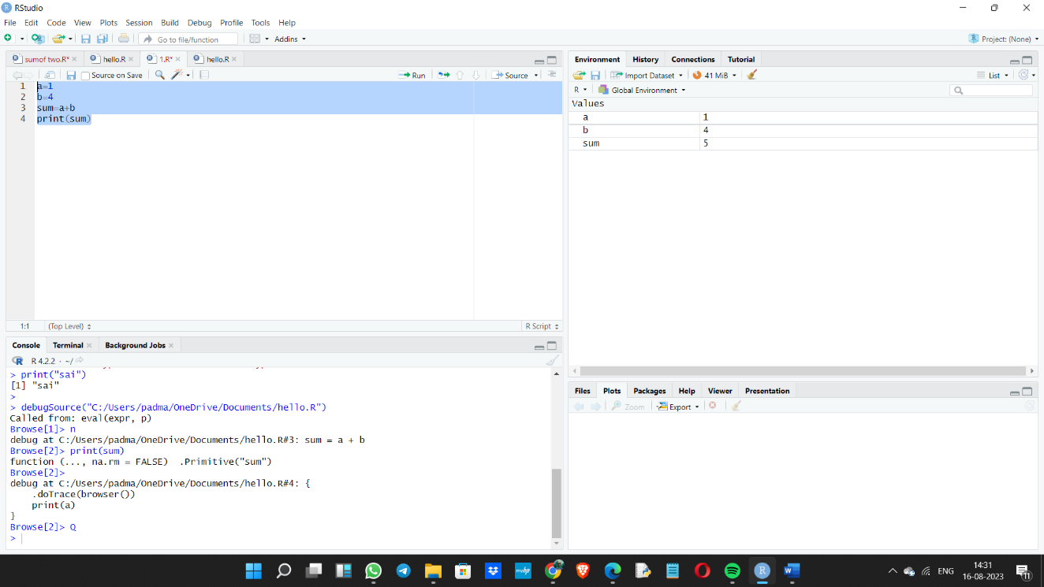print(sum)

2.Mean:

height <-c(150,174, 138, 186, 128, 136, 171, 163, 152, 131)

result.mean <-mean(height)

print(result.mean)

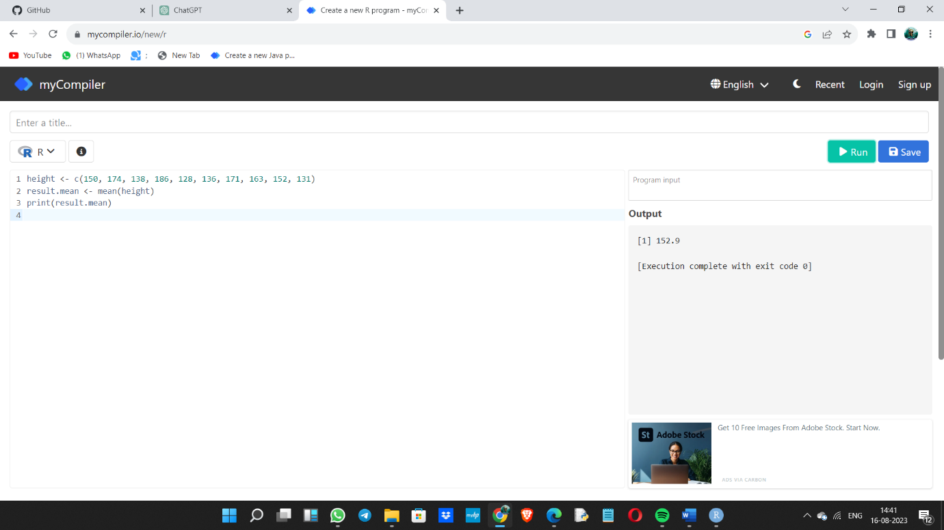

3.Bar plot:

temperatures <- c(20, 22, 25, 29, 23, 27, 28)

result <- barplot(temperatures,

main = "Maximum Temperatures in a Week",

xlab = "Degree Celsius",

ylab = "Day",

names.arg = c("Sun", "Mon", "Tue", "Wed", "Thu", "Fri", "Sat"),

col = "blue", )

print(result)

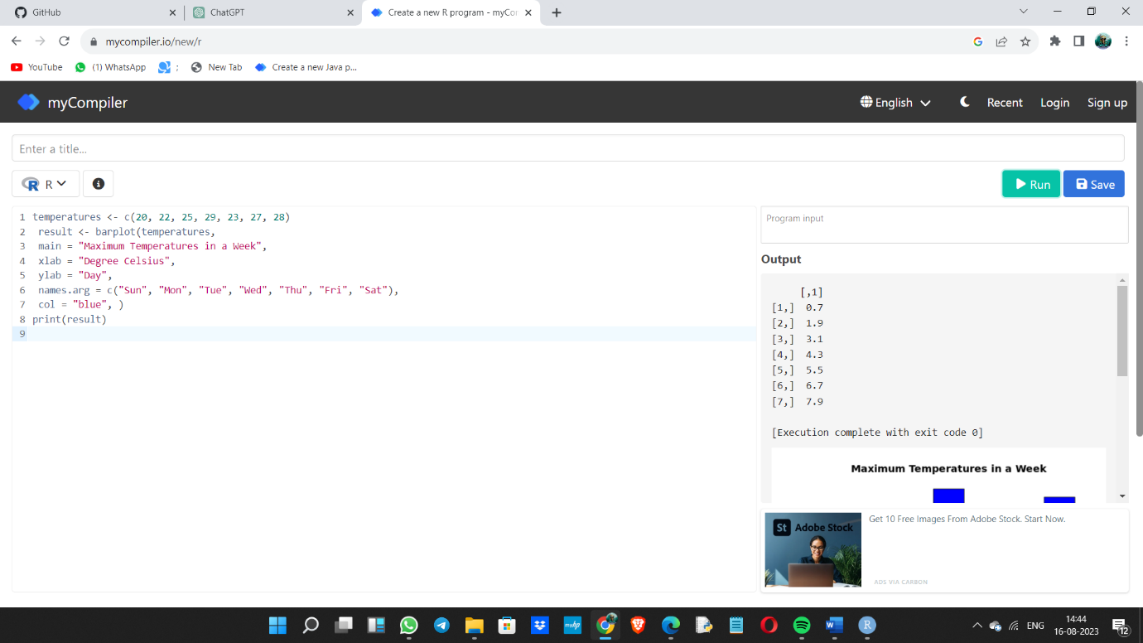

4.Box plot:

b <- c(10,12,13,14,17,19,20,30,50,70,90,100)

print(boxplot(b,col="green"))

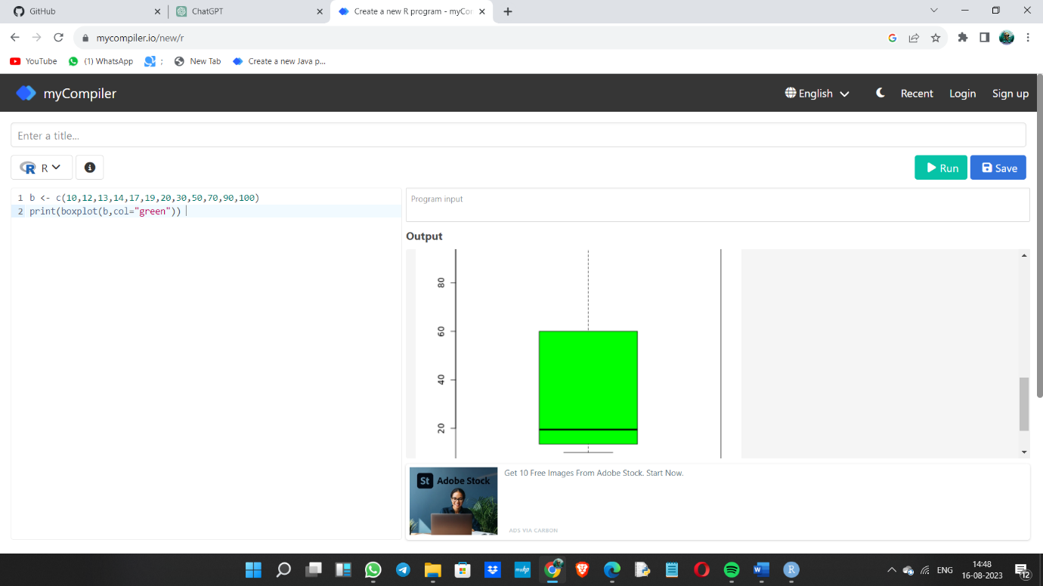

5.Decision tree:

library(rpart)

library(rpart.plot)

data=read.csv("C:\\Users\\arunk\\OneDrive\\Desktop\\DWDM\\Gender.csv") tree <- rpart(Height ~ Gender+Weight,data) a <- data.frame(Gender=c("Male"),Weight=c(85)) result <- predict(tree,a) print(result) rpart.plot(tree) tree1 <- rpart(Gender~ Height+Weight,data) a <- data.frame(Height=c(170),Weight=c(85)) re 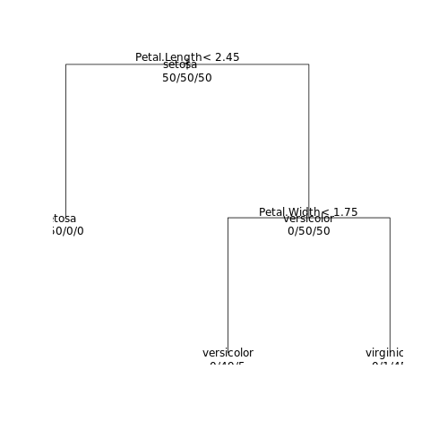sult <- predict(tree,a) print(result) rpart.plot(tree1)